In a regulated banking environment, For HCP Terraform platform, How can we download providers securely. List out all the options in detail. Environment consists of GitHub Enterprise, HCP Terraform, Git Hub actions for CI CD, Entra ID for SSO, CyberArk for vault.
Secure Terraform Provider Download Architecture for HCP Terraform – Regulated Banking Environment
For a regulated banking environment, I recommend implementing a centrally governed Terraform Provider Supply Chain rather than allowing HCP Terraform workspaces or individual developers to download providers directly from the public Terraform Registry.
Your environment consists of:
- HCP Terraform: Terraform execution, workspace management and private registry.
- GitHub Enterprise: Source control for Terraform configurations, modules and potentially approved provider artefacts.
- GitHub Actions: CI/CD pipelines for provider acquisition, security scanning, approval and publication.
- Microsoft Entra ID: SSO and identity management.
- CyberArk PAM: Secrets management, privileged credentials and access to protected systems.
The architecture should separate four activities:
- Provider acquisition – obtaining providers from trusted sources.
- Provider validation – scanning, verifying signatures and approving versions.
- Provider distribution – making approved providers available to HCP Terraform agents.
- Provider consumption – ensuring Terraform workspaces can only use approved providers.
An important distinction: Terraform modules and Terraform providers have different distribution mechanisms. Storing provider binaries in a GitHub repository does not automatically make them available through the Terraform provider installation mechanism. You need a compatible provider registry or provider network mirror.
1. Available options for securely downloading providers
There are six main approaches worth considering.
Option | Provider storage/distribution | Banking suitability
1. Direct download from public registry | registry.terraform.io | Low without additional controls
2. HCP Terraform private provider registry | HCP Terraform | High for internally developed providers
3. Network mirror using Nexus | Nexus Repository | Very high
4. Internal provider mirror hosted in GitHub Enterprise | GitHub Enterprise | High with additional engineering
5. Controlled provider acquisition and distribution pipeline | GitHub Actions + approved internal repository | Very high
6. Preloaded provider binaries in HCP Terraform agent images | Internal agent image repository | High for restricted environments
These approaches are not mutually exclusive. A banking organisation can combine several of them.
2. Option 1 – Direct download from the public Terraform Registry
Not recommended as the default banking approach
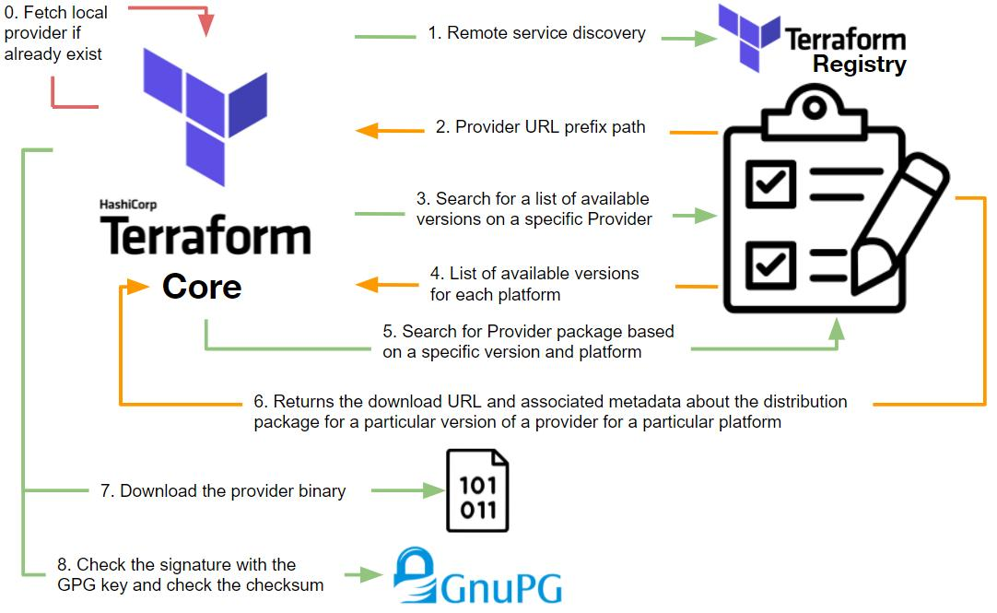
How it works
When a Terraform run starts, HCP Terraform identifies the providers required by the Terraform configuration and downloads the required provider packages from their origin registries.
For example:
terraform {
required_providers {
aws = {
source = "hashicorp/aws"
version = "6.0.0"
}

vsphere = {
source = "hashicorp/vsphere"
version = "2.12.0"
}
}
}
The normal process is:
- HCP Terraform starts a run.
- Terraform reads the required_providers configuration.
- Terraform resolves provider versions.
- It retrieves provider metadata and package download information.
- It downloads the provider package.
- It verifies package checksums against the provider's published checksums and the dependency lock file.
- It installs the provider and executes the Terraform plan.
Security considerations
Security control | Implementation
Provider version control | Pin provider versions
Integrity verification | Commit .terraform.lock.hcl
Source verification | Verify provider signing information
Provider governance | Sentinel policies to restrict approved providers
Audit | Retain HCP Terraform run logs
Network control | Restrict outbound access where possible
Advantages
- Simple to implement.
- No additional provider repository required.
- Providers are downloaded from their original publishers.
- Less operational overhead.
Disadvantages
- Terraform runs depend on external registry availability.
- Public provider versions can be introduced without internal approval unless additional controls exist.
- Difficult to demonstrate a complete internal acquisition, validation and release process.
- Does not provide a fully controlled internal provider distribution boundary.
An important distinction: HCP Terraform's private registry can curate public providers, but this does not mean their binaries are automatically copied into your private environment. Curated public providers still resolve to their public provider source.

HashiCorp Developer+2
3. Option 2 – HCP Terraform private provider registry
Recommended for internally developed providers
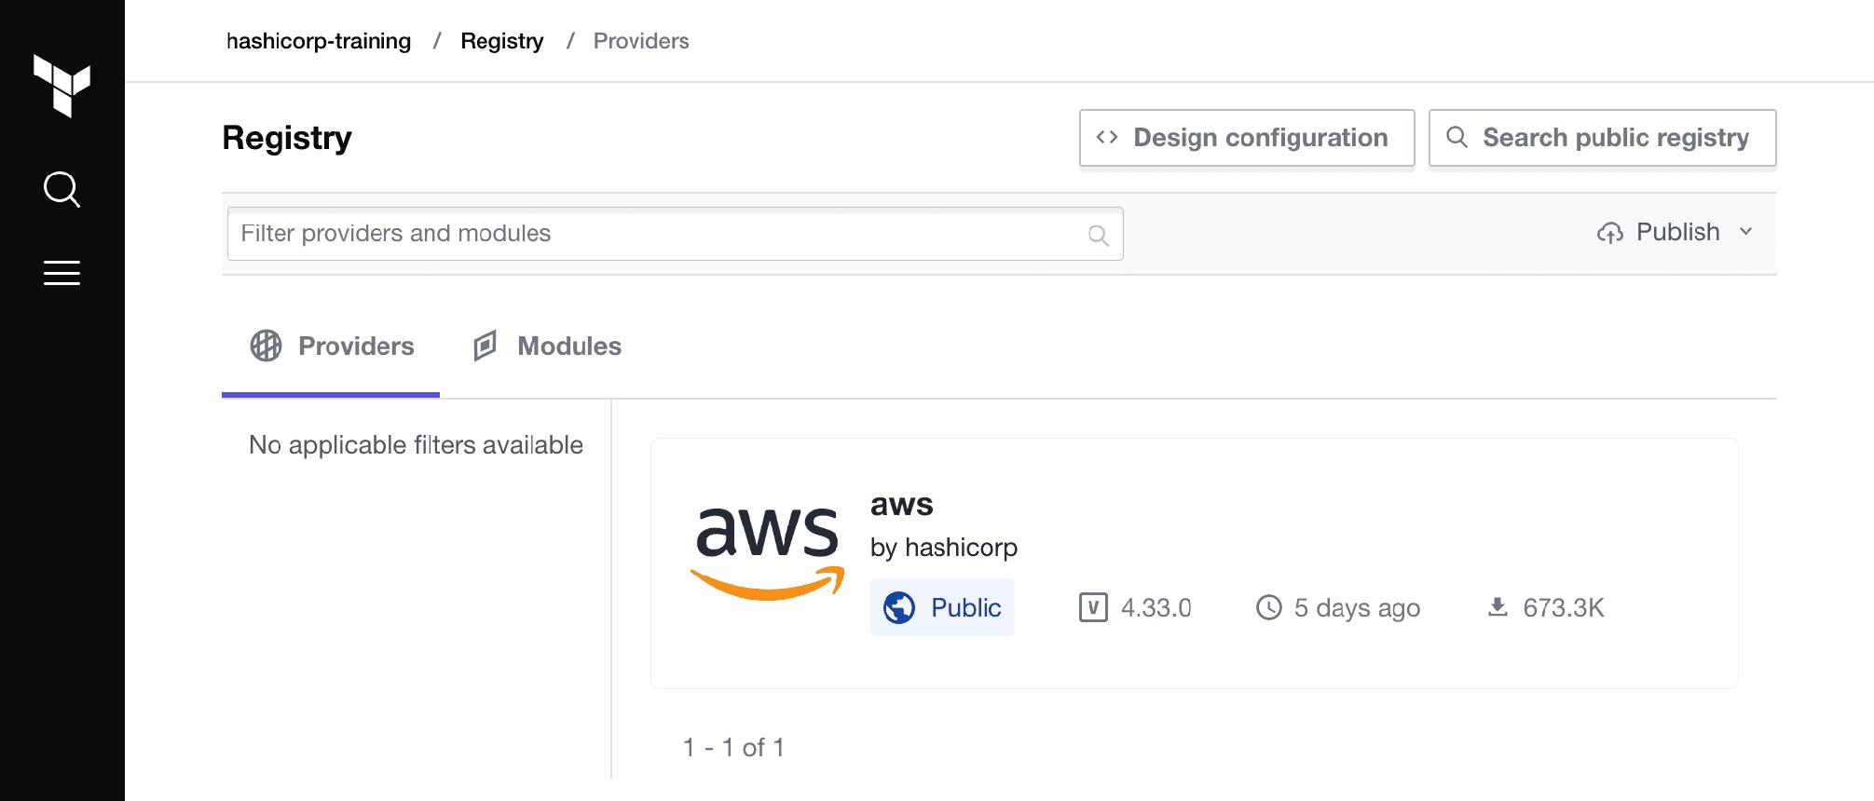
HCP Terraform provides a private registry that supports:
- Public provider curation.
- Private provider publication.
- Provider version management.
- Provider distribution to workspaces within the organisation.
There are two different use cases.
A. Curating public providers
For example, your banking organisation approves:
- AWS provider.
- VMware vSphere provider.
- Kubernetes provider.
- Azure provider.
- TLS provider.
The platform team adds these providers to the HCP Terraform private registry.
This provides a central catalogue of approved/recommended providers.
However, there is a significant limitation:
Public provider curation is not equivalent to downloading the binaries into HCP Terraform's private registry.
The provider source address still determines where Terraform obtains the provider package.
B. Publishing private providers
This is particularly useful if your organisation develops:
- Internal banking infrastructure providers.
- Custom VMware provisioning providers.
- Internal service-management providers.
- Proprietary infrastructure automation providers.
The process is:
- Develop the provider.
- Build the provider binaries using GitHub Actions.
- Generate SHA256 checksums.
- Sign the release using GPG.
- Upload the public signing key to HCP Terraform.
- Publish the provider version through the HCP Terraform Registry API.
- Upload the checksums, signature and binaries.
- Make the provider available to authorised workspaces.
For private providers, HashiCorp requires signed releases, including the checksum and signature files.
HashiCorp Developer+1
Example configuration:
terraform {
required_providers {
banking = {
source = "my-org/banking"
version = "1.0.0"
}
}
}
Advantages
- Native integration with HCP Terraform.
- Centralised provider version management.
- No separate provider registry infrastructure to maintain.
- Suitable for internally developed providers.
- Supports provider version publication through API automation.
Disadvantages
- Public provider curation does not internally mirror the binaries.
- Private providers need a signing and release process.
- You become responsible for maintaining and updating copied or internally developed provider releases.
- It is not a general-purpose internal mirror for automatically replicating every public provider.
My recommendation: Use this for internally developed providers, not as the sole mechanism for distributing all third-party public providers.
4. Option 3 – Nexus Repository as an internal provider repository
Strong recommendation if Nexus is already available
This is a strong option for a regulated banking organisation.
Nexus Repository can act as an internal distribution point, provided it is configured to serve Terraform providers using a compatible provider distribution mechanism.
There are two possible designs:
- Host an internal provider network mirror.
- Host an internal provider registry implementing the Terraform provider registry protocol.
These are different protocols and should not be confused.
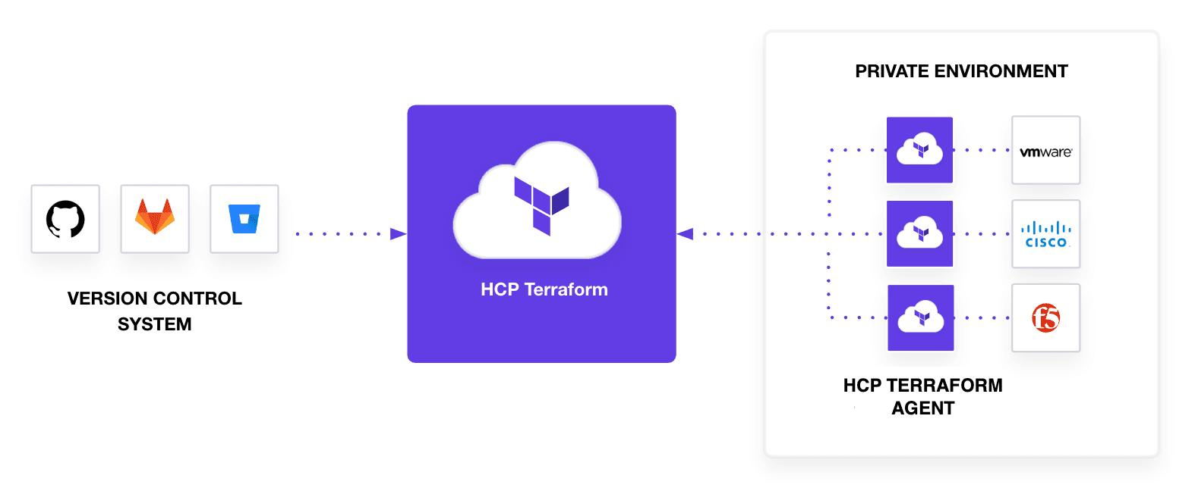
Proposed architecture
External Terraform Registry
|
|
Controlled Internet
|
v
GitHub Actions CI/CD
|
Provider acquisition
|
Security validation
|
Approval workflow
|
v
Nexus Repository
(Approved Providers)
|
|
Internal network
|
v
HCP Terraform Agent
|
v
Terraform Init
|
v
Provider Installation
|
v
vSphere / AWS / Azure
Implementation process
Step 1 – Provider acquisition
GitHub Actions downloads the provider from the original provider registry.
For example:
terraform providers mirror \
-platform=linux_amd64 \
./provider-mirror
For a banking platform, include every required execution platform, such as:
- Linux AMD64.
- Linux ARM64, if required.
- Windows AMD64, if required for developer tooling.
Step 2 – Security validation
The pipeline should perform:
- Checksum verification.
- GPG signature verification.
- Malware scanning.
- Software composition analysis.
- Vulnerability scanning.
- Provider source and publisher validation.
- Licence validation.
- Release and version approval.
Step 3 – Publication
After successful validation, the pipeline publishes the provider packages to Nexus.
Use immutable versioned paths and prevent developers from overwriting approved provider packages.
Step 4 – Provider consumption
Terraform agents need to retrieve the provider packages from Nexus.
A conventional Terraform CLI installation configuration looks like this:
provider_installation {
network_mirror {
url = "https://nexus.example.com/repository/terraform-providers/"
}
}
This requires the repository to implement the Terraform provider network mirror protocol.
Important HCP Terraform limitation
This is where architecture selection becomes important.
HashiCorp documents that HCP Terraform does not currently support activating a custom provider network mirror through its hosted run environment because the required provider_installation CLI configuration cannot be activated there.
HashiCorp Developer+2
Therefore:
- With HCP Terraform hosted execution, do not assume you can configure Nexus as a network mirror.
- With HCP Terraform agents, assess the agent execution environment and supported CLI configuration before designing around this mechanism.
- For a private registry implementation, use the provider registry protocol rather than assuming a network mirror is equivalent.
This is an important technical decision for your POC.
5. Option 4 – GitHub Enterprise as the provider storage repository
Possible, with some limitations
Since your organisation already uses GitHub Enterprise, you can use it as part of the provider supply chain.
There are three implementation approaches.
Approach A – Store provider binaries in a GitHub repository
Create a dedicated repository:
terraform-approved-providers
Suggested structure:
terraform-approved-providers/
│
├── aws/
│ ├── 6.0.0/
│ │ ├── terraform-provider-aws
│ │ ├── SHA256SUMS
│ │ └── SHA256SUMS.sig
│ │
│ └── 6.1.0/
│
├── vsphere/
│ ├── 2.12.0/
│ │ ├── terraform-provider-vsphere
│ │ ├── SHA256SUMS
│ │ └── SHA256SUMS.sig
│
└── kubernetes/
└── 2.38.0/
GitHub repository controls:
- Restrict write access to the platform engineering team.
- Require pull requests.
- Require two-person approval.
- Enable branch protection.
- Enable immutable release practices where supported.
- Enable audit logging.
- Restrict deletion and force pushes.
- Retain provider checksums and signatures.
Important limitation: GitHub is not automatically a Terraform provider registry. Terraform cannot simply use an arbitrary GitHub repository as its provider download source.
For HCP Terraform, HashiCorp documents an alternative for in-house providers: place the compiled provider binary in the workspace's configuration repository under the terraform.d/plugins directory, using the appropriate source address, version and platform structure.
For example:
terraform-configuration/
│
├── main.tf
├── versions.tf
├── terraform.tf
│
└── terraform.d/
└── plugins/
└── my-host/
└── my-namespace/
└── custom/
└── 1.0.0/
└── linux_amd64/
└── terraform-provider-custom
This is a documented option for custom providers, not a general-purpose mechanism for distributing all public providers.
HashiCorp Developer
Approach B – GitHub Releases as provider artefact storage
Instead of storing binaries directly in Git, use GitHub Releases.
For example:
Repository: terraform-approved-providers

Release: aws-v6.0.0
terraform-provider-aws_6.0.0_linux_amd64.zip
terraform-provider-aws_6.0.0_linux_arm64.zip
SHA256SUMS
SHA256SUMS.sig

Release: vsphere-v2.12.0
terraform-provider-vsphere_2.12.0_linux_amd64.zip
SHA256SUMS
SHA256SUMS.sig
Benefits:
- Keeps large binaries out of the Git repository history.
- Provides release versioning.
- Enables release approval workflows.
- Provides traceability.
- Allows separation between source code and provider artefacts.
However, GitHub Releases alone do not implement the Terraform provider registry protocol. HCP Terraform will not automatically treat a GitHub Release URL as a provider registry.
You would need an intermediate publishing mechanism, such as the HCP Terraform private provider registry API or an internal provider registry.
Approach C – GitHub as the source of truth, HCP Terraform as the distribution registry
This is a particularly interesting design for your environment.
Public Terraform Registry
|
v
GitHub Actions
|
Download provider
|
Security validation
|
Approval workflow
|
v
GitHub Enterprise
Approved Releases
|
v
GitHub Actions
Publication pipeline
|
v
HCP Terraform
Private Provider Registry
|
v
HCP Terraform Workspaces
Here:
- GitHub Enterprise maintains the approved provider artefact history.
- GitHub Actions performs the acquisition and security checks.
- HCP Terraform private registry distributes the published provider.
- Workspaces use the HCP Terraform private provider source.
This gives you a clear separation between provider approval and provider consumption.
One caveat: publishing a public provider as a private provider requires you to manage its new private namespace, release signatures, versions and subsequent updates. It is not an automatic synchronisation of public provider binaries.
6. Option 5 – GitHub Actions-based provider acquisition and approval pipeline
Highly recommended for your banking platform
This is the approach I would prioritise regardless of which repository or registry you select.
Rather than allowing developers to download providers, establish a centralised provider acquisition pipeline.
Proposed CI/CD architecture
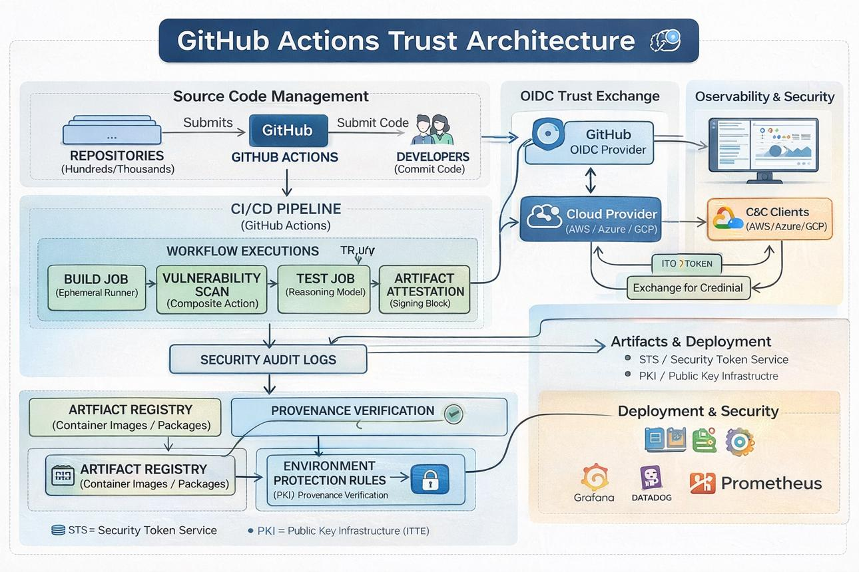
Detailed workflow
Stage | Activity | Security control
1. Request | Developer requests a provider/version | Approved request workflow
2. Acquisition | Download from original Terraform Registry | Trusted source allowlist
3. Integrity | Verify checksums and publisher signature | Cryptographic verification
4. Scanning | Scan provider package | Malware and vulnerability scanning
5. Analysis | Inspect provider source/release metadata | Publisher and licence validation
6. Testing | Run provider compatibility tests | Controlled test environment
7. Approval | Platform security approval | Separation of duties
8. Publication | Upload to approved repository/registry | Restricted publishing identity
9. Consumption | Make available to HCP Terraform | Approved version constraints
10. Monitoring | Monitor vulnerabilities and new releases | Continuous governance
Example GitHub Actions workflow
This is an illustrative pipeline, not a complete production security implementation.
name: Terraform Provider Approval

on:
workflow_dispatch:
inputs:
provider:
description: Provider name
required: true
version:
description: Provider version
required: true

permissions:
contents: read

jobs:
acquire:
runs-on: ubuntu-latest

steps:
- name: Checkout repository
uses: actions/checkout@v4

- name: Install Terraform
uses: hashicorp/setup-terraform@v3

- name: Download provider packages
run: |
terraform providers mirror \
-platform=linux_amd64 \
./provider-mirror

- name: Verify provider integrity
run: |
# Verify trusted publisher signatures
# Validate checksums
# Fail if validation fails
echo "Perform provider verification"

- name: Security scanning
run: |
# Run approved security scanners
echo "Perform provider scanning"

- name: Publish approved artefacts
run: |
# Publish to approved internal repository
echo "Publish approved provider"
For production, the pipeline should not simply trust the workflow input. It should validate the provider namespace, exact version, platform, lock-file hashes and expected signing identity against an approved request.
Also, pin GitHub Actions themselves to immutable commit SHAs rather than relying on mutable action tags.
Important security controls
A. Separate acquisition and publication pipelines
Do not allow the same developer or pipeline identity to download, approve and publish a provider without independent controls.
Recommended separation:
- Acquisition team: download and submit.
- Security team: validate and approve.
- Platform team: publish.
- Development teams: consume.
B. Prevent unauthorised provider versions
Maintain an approved-provider manifest:
providers:
- name: hashicorp/aws
version: 6.0.0
approved: true

- name: hashicorp/vsphere
version: 2.12.0
approved: true

- name: hashicorp/kubernetes
version: 2.38.0
approved: false
The manifest should be the authoritative input to the publication pipeline, not merely documentation.
C. Use immutable provider releases
Once a provider version is approved and published:
- Do not overwrite its binaries.
- Do not silently replace checksums.
- Do not change the source artefact.
- Publish a new version following the approval process.
D. Maintain a provider SBOM
Maintain a software bill of materials and provenance record for each approved provider version.
Record:
- Provider source address.
- Original publisher.
- Version.
- Operating system and architecture.
- SHA256 checksum.
- Signature verification result.
- Vulnerability scan results.
- Approval reference.
- Publication date.
- Repository location.
7. Option 6 – Preloading providers into HCP Terraform execution environments
This approach is worth considering for highly restricted or isolated banking networks.
The idea is to distribute provider binaries before Terraform runs, rather than downloading them during every run.
There are two related mechanisms.
A. Preloaded providers for custom providers
HCP Terraform supports placing in-house provider binaries inside the workspace configuration repository:
terraform.d/plugins/
This is useful for a custom provider that is not available in the public registry.
B. Provider cache and prebuilt execution environments
In standard Terraform CLI execution, provider installation can use:
- Filesystem mirrors.
- Plugin caches.
- Pre-downloaded provider binaries.
However, do not assume these standard Terraform CLI mechanisms are configurable in HCP Terraform's managed run environment.
HashiCorp explicitly documents the limitation around custom network mirrors in HCP Terraform.
HashiCorp Developer+2
For your platform, I would not make preloading the primary strategy for public providers.
8. Important distinction: HCP Terraform hosted execution versus HCP Terraform agents
This is probably the most important architectural decision in your environment.
Option A – HCP Terraform hosted execution
HashiCorp-managed workers
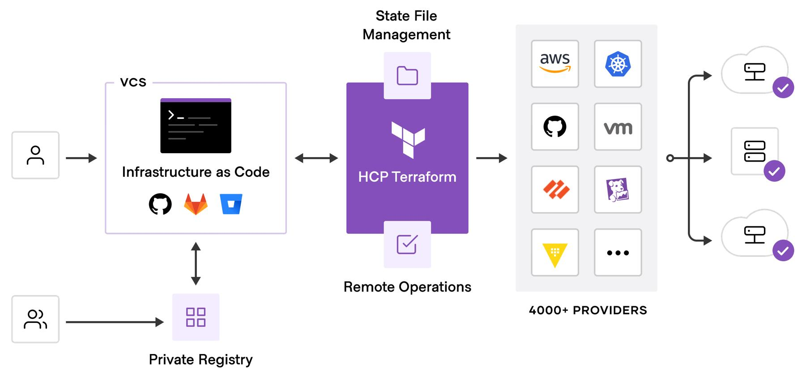
- Terraform runs execute on HashiCorp-managed workers.
- Provider downloads take place in the managed run environment.
- You cannot assume access to your internal Nexus repository.
- Your internal provider registry must be reachable from the managed execution environment.
- Custom provider network mirrors cannot be activated using the unsupported CLI configuration mechanism.
Option B – HCP Terraform self-hosted agents
Better suited to restricted banking networks
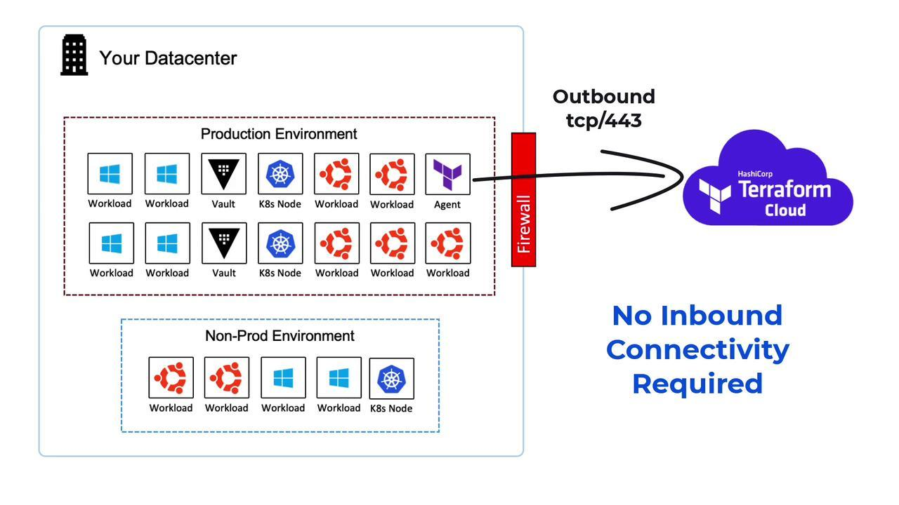
- Agent runs inside your controlled network.
- Agent can connect to internal Nexus and GitHub Enterprise.
- Agent can connect to internal vSphere infrastructure.
- Network traffic can be controlled using banking firewall policies.
- Agent requires outbound connectivity to HCP Terraform.
Important: The agent does not automatically remove HCP Terraform's provider mirror limitations. Confirm the supported installation configuration with HashiCorp before adopting a Nexus network-mirror design.
HashiCorp documents agents as a mechanism for managing isolated and on-premises infrastructure, including vSphere.
HashiCorp Developer+2
9. Recommended architecture for your banking environment
Considering your existing GitHub Enterprise, GitHub Actions, HCP Terraform, Entra ID and CyberArk setup, I would recommend the following design.
Recommended architecture
External provider sources
Terraform Registry / HashiCorp / Verified third-party publishers
GitHub Actions – Provider acquisition pipeline
Download
Approved sources and versions
Verify
Signatures and checksums
Scan
Vulnerability and malware checks
Approve
Security and platform approval
GitHub Enterprise
Immutable approved artefacts, release history and provenance
Nexus Repository
Optional internal provider registry or network mirror
Approved publication process
HCP Terraform Private Provider Registry
Published private providers and curated public provider catalogue
HCP Terraform Agent / Hosted Worker
Downloads approved providers and executes Terraform runs
Banking infrastructure
vSphere / AWS / Azure / Kubernetes
Cross-cutting security services
Entra ID
Human SSO and group-based access
CyberArk PAM
Secrets, API credentials and controlled signing-key access
How I would implement the architecture
I would use GitHub Enterprise as the source of truth for provider approval records and release artefacts, and HCP Terraform's private registry as the native distribution mechanism for providers that need to be used by HCP Terraform.
Nexus can remain available for other software artefacts and, where appropriate, an internal provider registry implementation.
This avoids making the entire HCP Terraform provider download process dependent on a custom network mirror that HCP Terraform does not support in its standard managed run environment.
10. Integration with Entra ID and CyberArk
These two components are important, but they serve different security purposes.
Component | Responsibility
Entra ID | Authenticate users accessing GitHub Enterprise and HCP Terraform
Entra ID groups | Map platform engineers, security approvers and developers to appropriate roles
GitHub Enterprise | Protect provider source repositories and releases
GitHub Actions | Automate acquisition, validation and publication
CyberArk PAM | Protect privileged credentials, API tokens and signing-key access
HCP Terraform RBAC | Restrict private provider publication and management
HCP Terraform Sentinel | Enforce provider governance policies where supported
CyberArk integration
I recommend:
- Store the HCP Terraform API publication credential in CyberArk.
- Use an approved machine identity or secrets retrieval mechanism for GitHub Actions.
- Avoid storing API tokens in GitHub repository secrets where a short-lived retrieval mechanism is available.
- Keep provider signing keys in an appropriately protected signing service or HSM.
- Audit all signing and publishing operations.
- Use separate credentials for acquisition and publication.
One important distinction: Entra ID SSO controls human access, but does not itself authenticate provider binaries. Similarly, CyberArk protects credentials; it does not replace cryptographic provider signature verification.
11. Mandatory security controls for provider downloads
I would establish the following minimum controls before permitting providers into production.
Control | Priority | Purpose
Approved provider namespace allowlist | Critical | Prevent untrusted providers
Exact provider version pinning | Critical | Prevent uncontrolled upgrades
.terraform.lock.hcl | Critical | Record approved package checksums
GPG signature verification | Critical | Verify trusted publisher signatures
SHA256 verification | Critical | Validate package integrity
Malware scanning | High | Detect malicious packages
Vulnerability scanning | High | Identify known vulnerabilities
Licence validation | High | Check legal compliance
SBOM generation | High | Maintain component inventory
Immutable artefact storage | Critical | Prevent binary replacement
Two-person publication approval | Critical | Separation of duties
Audit logging | Critical | Maintain evidence for compliance
Provider deprecation process | High | Manage vulnerable or unsupported versions
Example provider configuration
terraform {
required_version = ">= 1.9.0, < 2.0.0"

required_providers {
aws = {
source = "hashicorp/aws"
version = "= 6.0.0"
}

vsphere = {
source = "hashicorp/vsphere"
version = "= 2.12.0"
}
}
}
The versions are illustrative; approve them through your provider governance process.
Commit the generated .terraform.lock.hcl file into GitHub Enterprise.
The lock file should be reviewed and updated through the controlled provider approval pipeline. It provides checksum protection, but it does not independently establish that a provider is approved by your organisation.
12. Comparison of the options
Here is how I would evaluate them for your banking environment.
Criteria | Public Registry | HCP Private Registry | Nexus | GitHub Enterprise
Provider version management | Yes | Yes | Depends on implementation | Release-based
Internal approval | External controls needed | Yes, for publishing | Yes | Yes
Stores provider binaries internally | No | Yes, for private providers | Yes | Yes
Native HCP integration | Yes | Yes | Registry protocol required | Limited
Automated CI/CD | Yes | Yes, API | Yes | Yes
Offline/restricted distribution | No | Depends on execution connectivity | Possible | Possible internally
Auditability | Limited organisational control | Good | Good | Good
Recommended role | Upstream source | HCP distribution | Optional internal distribution | Approval and artefact source
13. My final recommendation
For your particular platform, I would prioritise these three approaches:
1. GitHub Actions + GitHub Enterprise
Essential
Use this for controlled provider acquisition, validation, security scanning, approval, immutable storage and audit evidence.
2. HCP Terraform private provider registry
Preferred distribution
Use this for publishing approved private provider releases and distributing them natively to HCP Terraform workspaces. Curate public providers separately, recognising that curation does not copy their binaries.
3. Nexus Repository
Complementary
Retain Nexus for internal artefact distribution or a compatible provider registry/network mirror where the execution model supports it. Do not assume its network mirror can be configured in standard HCP Terraform remote runs.
14. Questions to confirm with HashiCorp during your HCP Terraform POC
I would specifically raise these questions with the vendor:
- Can HCP Terraform download all public provider packages exclusively from an internally hosted provider registry?
- Can we publish copies of public providers as private providers through the Registry API, and what are the operational implications?
- Can HCP Terraform agents use an internally hosted provider registry implementing the provider registry protocol?
- Is there any supported mechanism to configure TF_CLI_CONFIG_FILE or provider_installation for HCP Terraform agent runs?
- Can we prevent workspaces from using providers outside an organisation-approved provider allowlist?
- Can Sentinel policies enforce provider namespace and version restrictions before an apply?
- What is the supported method for managing provider signing keys and release verification?
- What are the network endpoints and firewall requirements for provider downloads in hosted and agent execution modes?
- Can we obtain complete audit evidence of provider version, checksum, source and download activity for each run?
- What is the recommended approach for disaster recovery if the original public Terraform Registry becomes unavailable?
The most important POC acceptance criterion: Demonstrate that an HCP Terraform workspace can successfully initialise and execute a plan using an approved provider without directly downloading that provider from the public Terraform Registry.
This will validate whether your selected distribution mechanism actually meets the banking security requirement.
Useful official documentation:
- HCP Terraform private registry overview
- Publishing private providers
- Installing software in HCP Terraform run environments
- Terraform provider network mirror protocol
- HCP Terraform agents
I can also develop a detailed provider supply-chain architecture and implementation runbook, covering GitHub Actions workflows, Nexus versus GitHub storage, HCP Terraform Registry API publication, CyberArk integration, firewall rules and POC acceptance tests.
This might also interest you.
In a regulated banking environment, For HCP Terraform platform, How can we download providers securely without Nexus. Provide detailed instructions
Secure Terraform Provider Download Without Nexus – HCP Terraform Banking Architecture
For your regulated banking environment, you can implement a secure Terraform provider supply chain without Nexus, using the existing GitHub Enterprise, GitHub Actions and HCP Terraform capabilities.
My recommendation is to use:
- GitHub Enterprise: Approved provider artefact storage, version control and audit trail.
- GitHub Actions: Provider acquisition, signature verification, security scanning and controlled publication.
- HCP Terraform Private Registry: Distribution of internally published providers and management of the approved provider catalogue.
- HCP Terraform Agents: Execution within your controlled banking network, where required.
- Microsoft Entra ID: User authentication and role-based access.
- CyberArk PAM: Secure storage and retrieval of API credentials and signing credentials.
There are two important architectural choices:
- Use GitHub Enterprise as the internal provider artefact source and configure a supported distribution mechanism for the execution environment.
- Publish approved provider binaries into HCP Terraform's private registry, so HCP Terraform can distribute them natively.
Important: GitHub repositories and GitHub Releases are not automatically Terraform provider registries. Likewise, the HCP Terraform private registry does not automatically mirror every public provider binary. The publication mechanism must be designed accordingly.
I would implement a controlled acquisition pipeline with independent security approval, immutable provider versions and cryptographic verification.
1. Available options without Nexus
There are four realistic approaches.
Option | How it works | Recommendation
A. Direct public registry with security controls | HCP Terraform downloads from Terraform Registry | Suitable if external downloads are permitted
B. GitHub Enterprise + HCP private registry | GitHub Actions downloads, verifies and publishes provider binaries to HCP | Recommended
C. GitHub-hosted private provider registry | GitHub-backed service implements Terraform provider registry protocol | Possible, but requires development and maintenance
D. Provider binaries inside configuration repository | Store custom provider binaries under terraform.d/plugins | Only for specific in-house providers
I would select Option B for your banking implementation.
There is an important distinction between two HCP Terraform features:
- Public provider curation: adds public providers to your organisation's catalogue, but the public provider remains sourced from the public registry.
- Private provider publication: uploads provider binaries, checksums and signatures into HCP Terraform's private registry.
The second approach is what you need if the requirement is to download, validate, approve and internally control provider versions before production use.
HashiCorp Developer+2
2. Option A – Direct public registry with security controls
Suitable only if public registry access is permitted
In this model, you don't maintain a separate provider binary repository.
Architecture
GitHub Enterprise
|
v
GitHub Actions
|
Provider validation
|
Update lock file
|
v
HCP Terraform
|
Terraform Init
|
v
Public Registry
registry.terraform.io
|
v
Provider installed
Implementation instructions
Step 1 – Define approved providers
Create a GitHub repository:
terraform-provider-governance
Example:
providers:
- source: hashicorp/aws
version: "6.0.0"
approved: true

- source: hashicorp/vsphere
version: "2.12.0"
approved: true

- source: hashicorp/kubernetes
version: "2.38.0"
approved: false
Step 2 – Enforce provider versions
In Terraform configuration:
terraform {
required_providers {
aws = {
source = "hashicorp/aws"
version = "= 6.0.0"
}

vsphere = {
source = "hashicorp/vsphere"
version = "= 2.12.0"
}
}
}
Step 3 – Generate the dependency lock file
On a controlled GitHub Actions runner:
terraform init
terraform providers lock \
-platform=linux_amd64 \
-platform=windows_amd64
Commit the resulting .terraform.lock.hcl through a pull request.
Step 4 – Apply security policies
Use Sentinel policies to check:
- Provider source addresses.
- Approved provider versions.
- Unapproved providers.
- Version constraints.
- Other organisation-specific deployment requirements.
Step 5 – Restrict outbound access
Permit only the required external registry and download endpoints, as confirmed through network testing and HashiCorp documentation.
Limitations
- Provider binaries still originate from public sources.
- HCP Terraform execution requires external registry access.
- You cannot guarantee that every provider is internally retained.
- An external registry outage can affect provider installation.
This option is a controlled public download approach, not an internal provider distribution architecture.
3. Option B – GitHub Enterprise + HCP Terraform Private Registry
Recommended for your banking environment
This is the approach I would implement.
The main idea is:
Download providers once, validate them, obtain security approval, store the approved release in GitHub Enterprise and publish the provider to HCP Terraform's private registry.
After publication, HCP Terraform workspaces consume the approved provider from the private registry instead of downloading it from the original public registry.
3.1 Target architecture
External provider publishers
HashiCorp / AWS / VMware / Kubernetes / Community publishers
GitHub Actions – Acquisition pipeline
- Download exact provider version
- Verify original publisher signature
- Verify SHA256 checksums
- Scan provider package
- Generate SBOM
Security approval
Security team approval
Platform engineering approval
Release evidence and provenance
GitHub Enterprise
Approved provider artefacts, release metadata, signatures and checksums
GitHub Actions – Publication pipeline
HCP Terraform Registry API
HCP Terraform Private Provider Registry
Approved provider binaries and versions
HCP Terraform workspaces
Install approved providers and execute Terraform plans
Security services
Entra ID
SSO and human RBAC
CyberArk
API and signing credentials
3.2 Step-by-step implementation
Step 1 – Create GitHub repositories
I recommend separating provider governance from provider artefacts.
Repository | Responsibility
terraform-provider-catalogue | Approved providers, versions and governance metadata
terraform-provider-acquisition | GitHub Actions acquisition and validation workflows
terraform-approved-provider-artifacts | Approved release packages and evidence
terraform-provider-publishing | HCP Terraform registry publication automation
You can combine some of these repositories initially, but keeping acquisition, approval and publication workflows separate is better for a regulated platform.
Step 2 – Define provider approval manifest
In terraform-provider-catalogue, create:
approved-providers.yaml
providers:
- name: aws
source: hashicorp/aws
version: 6.0.0
platforms:
- linux_amd64
approval_status: approved
owner: cloud-platform

- name: vsphere
source: hashicorp/vsphere
version: 2.12.0
platforms:
- linux_amd64
approval_status: approved
owner: infrastructure-platform

- name: kubernetes
source: hashicorp/kubernetes
version: 2.38.0
platforms:
- linux_amd64
approval_status: pending
owner: container-platform
This manifest becomes the authoritative list of providers that the acquisition and publication pipelines are allowed to process.
Step 3 – Download provider packages
Use a dedicated GitHub Actions runner with controlled outbound internet access.
The runner should:
- Have no production infrastructure credentials.
- Access only approved provider sources.
- Run in an isolated build environment.
- Use a pinned Terraform CLI version.
- Retain download and verification logs.
One way to download provider packages is to create a temporary Terraform configuration.
Example:
terraform {
required_providers {
aws = {
source = "hashicorp/aws"
version = "= 6.0.0"
}
}
}
Run:
terraform init

terraform providers mirror \
-platform=linux_amd64 \
./provider-download
This downloads the provider packages and generates the filesystem mirror layout.
For a complete banking release process, obtain the original publisher's signed checksum file and signature as well. The mirror command alone should not be treated as proof that the original publisher's signature has been verified.
HashiCorp Developer+1
Step 4 – Verify provider authenticity
This is a mandatory security stage.
For each provider:
- Identify the original provider publisher.
- Retrieve the publisher's trusted public signing key through an independently verified channel.
- Verify the key fingerprint.
- Download the official checksum file.
- Download the associated signature.
- Verify the signature against the trusted key.
- Verify the downloaded ZIP file against the signed checksum.
- Reject any package that fails verification.
Example:
gpg --import publisher-public-key.asc

gpg --verify SHA256SUMS.sig SHA256SUMS

sha256sum -c SHA256SUMS
Do not automatically trust a key just because it was downloaded alongside the provider package.
For third-party providers, use the publisher's documented signing key and verification procedure. If the publisher does not provide verifiable signed releases, treat that as an exception requiring security risk acceptance rather than silently substituting an internally generated signature.
Step 5 – Perform security scanning
Run the following checks before publication:
Security test | Purpose
Malware scanning | Identify malicious binaries
Vulnerability scanning | Detect known vulnerabilities
SBOM generation | Identify package components
Publisher verification | Confirm provider provenance
Licence scanning | Check usage restrictions
Binary integrity | Confirm checksums
Static analysis | Assess available provider source code
Release validation | Confirm version and platform
Keep the output in the corresponding provider release evidence folder.
Example:
aws/
6.0.0/
linux_amd64/
provider.zip
SHA256SUMS
SHA256SUMS.sig
publisher-key-fingerprint.txt
sbom.json
vulnerability-report.json
malware-scan-report.json
approval.json
Step 6 – Publish approved artefacts to GitHub Enterprise
Only after security approval should the publication pipeline make the release available.
I recommend GitHub Releases rather than committing large provider binaries into normal Git history.
Example:
Repository:
terraform-approved-provider-artifacts

Release:
aws-6.0.0

Assets:
terraform-provider-aws_6.0.0_linux_amd64.zip
terraform-provider-aws_6.0.0_SHA256SUMS
terraform-provider-aws_6.0.0_SHA256SUMS.sig
sbom.json
approval.json
vulnerability-report.json
Apply these controls:
- Restrict release publication to the platform team.
- Require independent approval.
- Protect release tags.
- Prevent overwriting existing approved versions.
- Enable repository audit logging.
- Retain evidence for the banking audit retention period.
GitHub Enterprise is now your internal approved artefact source.
3.3 Step 7 – Publish providers to HCP Terraform Private Registry
This is the most important technical step.
HCP Terraform supports uploading private provider releases through its Registry API.
You need to publish five things:
- Provider metadata.
- Provider signing key reference.
- Provider version.
- Provider platform information.
- Provider binary, signed checksum file and checksum signature.
HashiCorp documents this API-based publication process.
HashiCorp Developer+1
A. Create provider in HCP Terraform
For example, suppose your HCP Terraform organisation is:
banking-platform
And you want to publish AWS provider version 6.0.0.
Create provider.json:
{
"data": {
"type": "registry-providers",
"attributes": {
"name": "aws",
"namespace": "banking-platform",
"registry-name": "private"
}
}
}
Call the HCP Terraform API:
curl \
--header "Authorization: Bearer $TFC_TOKEN" \
--header "Content-Type: application/vnd.api+json" \
--request POST \
--data @provider.json \
https://app.terraform.io/api/v2/organizations/banking-platform/registry-providers
The provider is now registered, but it is not yet consumable.
B. Configure the signing key
For an official HashiCorp provider, use HashiCorp's official public PGP key.
The documented key ID is:
34365D9472D7468F
For AWS provider releases signed by HashiCorp, use the original publisher's signature rather than creating a new signature yourself.
For non-HashiCorp providers, register the appropriate publisher public key in HCP Terraform.
HashiCorp documents that private providers require GPG-signed releases and that the public signing key must be available to HCP Terraform.
HashiCorp Developer+1
C. Create provider version
Create version.json:
{
"data": {
"type": "registry-provider-versions",
"attributes": {
"version": "6.0.0",
"key-id": "34365D9472D7468F",
"protocols": ["5.0"]
}
}
}
Publish the version:
curl \
--header "Authorization: Bearer $TFC_TOKEN" \
--header "Content-Type: application/vnd.api+json" \
--request POST \
--data @version.json \
https://app.terraform.io/api/v2/organizations/banking-platform/registry-providers/private/banking-platform/aws/versions
The API response provides upload URLs for the checksum and signature files.
D. Upload checksum and signature files
Use the upload URLs returned by HCP Terraform.
curl -T SHA256SUMS \
"$SHASUMS_UPLOAD_URL"

curl -T SHA256SUMS.sig \
"$SIGNATURE_UPLOAD_URL"
These URLs are generated by HCP Terraform. Do not hardcode or reuse them between releases.
E. Create provider platform
For example, Linux AMD64:
Create platform.json:
{
"data": {
"type": "registry-provider-version-platforms",
"attributes": {
"os": "linux",
"arch": "amd64",
"shasum": "YOUR_VERIFIED_SHA256",
"filename": "terraform-provider-aws_6.0.0_linux_amd64.zip"
}
}
}
Publish:
curl \
--header "Authorization: Bearer $TFC_TOKEN" \
--header "Content-Type: application/vnd.api+json" \
--request POST \
--data @platform.json \
https://app.terraform.io/api/v2/organizations/banking-platform/registry-providers/private/banking-platform/aws/versions/6.0.0/platforms
The response provides a provider binary upload URL.
F. Upload provider binary
curl -T terraform-provider-aws_6.0.0_linux_amd64.zip \
"$PROVIDER_BINARY_UPLOAD_URL"
Repeat for each approved operating system and architecture.
Important: These are the actual API operations, but the example is illustrative. Your pipeline must process the API responses dynamically, handle existing provider/version conflicts, validate every upload response and fail closed if any required release file is missing.
HashiCorp's documentation describes the full sequence, including creating platforms and uploading release files.
HashiCorp Developer+1
3.4 Step 8 – Configure Terraform to consume the private provider
Once published, update the Terraform configuration to use the private provider source address.
For example:
terraform {
required_providers {
aws = {
source = "app.terraform.io/banking-platform/aws"
version = "= 6.0.0"
}
}
}
Notice the difference:
Original source | Private source
hashicorp/aws | app.terraform.io/banking-platform/aws
hashicorp/vsphere | app.terraform.io/banking-platform/vsphere
The namespace and provider source address change because you are publishing the release as a private provider.
Generate the new dependency lock file:
terraform init
terraform providers lock -platform=linux_amd64
Commit .terraform.lock.hcl to GitHub Enterprise through a reviewed pull request.
What happens during Terraform execution?
- HCP Terraform starts the workspace run.
- Terraform reads the provider source from the configuration.
- Terraform resolves the private provider version.
- HCP Terraform accesses the organisation's private registry.
- The registry supplies the approved provider package.
- Terraform validates the package against the recorded hashes.
- Terraform installs the provider.
- Terraform executes the plan.
Your Terraform workspace no longer needs to obtain that provider from the original public registry.
3.5 Step 9 – Automate the complete process in GitHub Actions
I would split this into two workflows.
Pipeline 1 – Provider acquisition and approval
- Read approved provider manifest.
- Download requested version from original publisher.
- Verify original signature and checksum.
- Run malware and vulnerability scans.
- Generate SBOM and provenance evidence.
- Request security approval.
- Publish immutable GitHub Release.
Pipeline 2 – HCP Terraform publication
- Retrieve approved GitHub Release.
- Revalidate checksum and signature.
- Retrieve HCP Terraform API credential from CyberArk.
- Create provider version and platform.
- Upload checksum, signature and binary.
- Verify provider availability in HCP Terraform.
- Record publication evidence.
Example GitHub Actions publication workflow
This illustrates the workflow structure. The actual API payload generation and upload URL handling should be implemented as reusable scripts.
name: Publish Approved Terraform Provider

on:
workflow_dispatch:
inputs:
provider:
description: Provider name
required: true
version:
description: Approved provider version
required: true

permissions:
contents: read

jobs:
publish:
runs-on: [self-hosted, provider-publisher]

environment: terraform-provider-production

steps:
- name: Checkout provider catalogue
uses: actions/checkout@<APPROVED_COMMIT_SHA>

- name: Validate provider approval
run: |
./scripts/validate-approval.sh \
"${{ inputs.provider }}" \
"${{ inputs.version }}"

- name: Retrieve approved artefacts
run: |
./scripts/download-approved-release.sh

- name: Verify provider signature
run: |
./scripts/verify-provider.sh

- name: Retrieve HCP API token
run: |
./scripts/get-cyberark-secret.sh

- name: Publish to HCP Terraform
run: |
./scripts/publish-provider.sh

- name: Verify publication
run: |
./scripts/verify-publication.sh
Production implementation requirements:
- Pin every GitHub Action to a full commit SHA.
- Use protected GitHub Environments with independent reviewers.
- Restrict the runner's outbound network access.
- Do not print API credentials into logs.
- Use a dedicated HCP Terraform service identity.
- Ensure the publisher cannot approve its own release.
- Use immutable artefacts and release version checks.
- Delete temporary credentials and working files after completion.
CyberArk integration
The API token retrieval should follow this sequence:
GitHub Actions
|
| Authenticated machine identity
v
CyberArk
|
| Retrieve authorised secret
v
HCP Terraform API token
|
v
HCP Terraform Registry API
Prefer a short-lived credential or supported machine identity integration. If a static HCP Terraform API token is unavoidable, restrict its permissions, protect it in CyberArk and rotate it according to policy.
Do not use a human owner's personal API token for the pipeline.
4. Option C – Host your own provider registry using GitHub Enterprise
Alternative – requires engineering effort
You can develop an internal Terraform provider registry without Nexus.
The architecture would be:
Terraform Registry
|
v
GitHub Actions
|
Download and scan
|
v
GitHub Enterprise
Provider binaries
|
v
Internal Provider Registry
(Registry API service)
|
v
HCP Terraform
|
v
Terraform
How it works
Terraform supports two different distribution protocols:
Protocol | Purpose
Provider Registry Protocol | Acts as an origin registry for providers with a specific source hostname
Provider Network Mirror Protocol | Mirrors providers from their original source addresses
The distinction matters because HCP Terraform currently documents a limitation with custom network mirrors, but supports private provider registries implementing the provider registry protocol.
HashiCorp Developer+1
Implementation
You would need to build a service that:
- Implements Terraform registry discovery.
- Implements provider version lookup.
- Returns supported operating systems and architectures.
- Provides secure download URLs.
- Serves signed provider packages.
- Provides checksum information.
- Authenticates and authorises provider downloads.
- Records download activity.
GitHub Enterprise would store the binaries and metadata, while the registry service would expose the required API endpoints.
For example, your internal provider source could be:
terraform {
required_providers {
aws = {
source = "terraform.bank.example/banking/aws"
version = "6.0.0"
}
}
}
Here, terraform.bank.example is the hostname of your internal provider registry.
Advantages
- Full control over provider distribution.
- No Nexus dependency.
- GitHub Enterprise remains the artefact source.
- Supports internal provider naming and governance.
- Can be integrated with your internal identity and audit infrastructure.
Disadvantages
- You must develop and maintain a registry service.
- You must implement the required registry protocol correctly.
- You must manage authentication, availability, scaling and disaster recovery.
- You need to ensure HCP Terraform execution environments can reach the registry.
- You introduce an additional application into the critical Terraform execution path.
My view: I would not build this unless your bank has a specific requirement to operate its own provider registry. HCP Terraform's native private registry is simpler to operate.
5. Option D – Store provider binaries directly in GitHub configuration repositories
Limited use case
HCP Terraform supports another mechanism for in-house custom providers.
You can store the provider binary inside the Terraform configuration repository.
Example:
terraform-vsphere-project/
│
├── main.tf
├── versions.tf
├── terraform.tf
│
└── terraform.d/
└── plugins/
└── my-host/
└── my-namespace/
└── custom/
└── 1.0.0/
└── linux_amd64/
└── terraform-provider-custom
Configuration:
terraform {
required_providers {
custom = {
source = "my-host/my-namespace/custom"
version = "1.0.0"
}
}
}
HCP Terraform can use this binary when it is included in the configuration version.
HashiCorp documents this as a supported method for in-house providers.
HashiCorp Developer+1
However, I would avoid this for public providers such as AWS, vSphere and Kubernetes because:
- You duplicate binaries across configuration repositories.
- Updating provider versions becomes difficult.
- Git repository size increases.
- Provider governance becomes fragmented.
- Different teams could end up consuming different unapproved binaries.
Use it only for a small number of internally developed custom providers.
6. Important: HCP Terraform hosted execution versus self-hosted agents
Your decision also depends on where Terraform runs.
Feature | Hosted execution | Self-hosted agent
Runs on HashiCorp infrastructure | Yes | No, runs in your environment
Access to GitHub Enterprise | Depends on connectivity and VCS integration | Depends on internal network
Access to internal provider registry | Requires suitable connectivity | Can access if network permits
Private HCP registry | Supported | Supported
Custom provider network mirror through CLI configuration | Not supported | Do not assume supported
Direct public registry access | Normally available subject to service connectivity | Subject to your firewall
An important correction to a common assumption: deploying HCP Terraform agents does not automatically enable a custom network mirror. HashiCorp explicitly documents the limitation in its HCP Terraform run-environment guidance.
HashiCorp Developer+1
For your vSphere provisioning POC, I would use HCP Terraform agents if your bank requires execution within its controlled network. However, I would still use the HCP private provider registry for the provider distribution mechanism.
7. Security controls for the complete solution
For a regulated banking implementation, I would make these controls mandatory.
Security control | Implementation | Priority
Provider allowlisting | Approved provider catalogue | Critical
Version pinning | Exact version constraints | Critical
Signature verification | Original publisher GPG key | Critical
Checksum validation | SHA256 verification | Critical
Malware scanning | Approved enterprise scanner | High
Vulnerability scanning | Provider binary/source assessment | High
SBOM | Generate for every approved release | High
Artefact immutability | Protected GitHub Releases | Critical
Separation of duties | Independent approval and publication | Critical
API credential management | CyberArk | Critical
SSO | Entra ID | High
Registry RBAC | HCP Terraform team permissions | Critical
Provider usage policy | Sentinel | Critical
Audit evidence | GitHub and HCP Terraform logs | Critical
Version retirement | Controlled deprecation and replacement | High
8. Recommended RBAC model
I would establish the following responsibilities.
Role | GitHub Enterprise | HCP Terraform
Provider requester | Submit provider request | No registry write access
Acquisition engineer | Run acquisition pipeline | No provider deletion
Security reviewer | Review scan results and approve | Read-only
Provider publisher | Publish approved release | Manage Private Registry
Platform administrator | Manage repositories and workflows | Organisation administration
Terraform developer | Read approved artefacts | Consume approved providers
Auditor | Read approval and audit evidence | Read-only access
Avoid granting developers permission to publish or delete providers.
Entra ID groups should be mapped to the relevant GitHub Enterprise and HCP Terraform teams.
9. Final comparison and recommendation
Criteria | Option A: Public registry | Option B: HCP private registry | Option C: Custom registry | Option D: Binary in Git
No Nexus required | Yes | Yes | Yes | Yes
Internal binary retention | No | Yes | Yes | Yes
Native HCP integration | Yes | Yes | Requires implementation | Limited use case
GitHub Actions automation | Yes | Yes | Yes | Yes
Provider approval workflow | Yes, external controls | Yes | Yes | Yes
Operational complexity | Low | Medium | High | Medium
My recommendation | Secondary | Primary | Avoid unless needed | Custom providers only
10. Implementation roadmap for your banking POC
I would break the implementation into six work packages.
Work package | Activities | Estimated effort
WP1 – Governance | Provider catalogue, approval process and RBAC | 2–3 days
WP2 – Acquisition | GitHub Actions download and signature verification | 3–4 days
WP3 – Security | Scanning, SBOM, checksum and approval integration | 3–5 days
WP4 – GitHub storage | Protected release repository and immutable artefacts | 1–2 days
WP5 – HCP publication | Registry API automation and CyberArk integration | 3–5 days
WP6 – Testing | Workspace integration, policy enforcement and audit testing | 2–3 days
Indicative engineering effort, assuming GitHub Enterprise, CyberArk and HCP Terraform are already available. Some activities can run in parallel.
Suggested POC acceptance criteria
- Download an AWS provider from the official publisher.
- Verify its original GPG signature and checksum.
- Perform malware and vulnerability scanning.
- Obtain independent security approval.
- Publish the approved provider release to GitHub Enterprise.
- Automatically publish the provider into HCP Terraform's private registry.
- Confirm the provider is available under the bank's private namespace.
- Execute terraform init from an HCP Terraform workspace.
- Confirm the workspace uses the private provider source.
- Confirm the workspace can execute a Terraform plan without downloading that provider from the public Terraform Registry.
- Confirm an unapproved provider is rejected by policy.
- Produce an auditable record of acquisition, approval, signature verification and publication.
11. Final architecture I would select
Recommended for implementation
GitHub Enterprise → HCP Terraform Private Registry
Public Terraform Registry
Original provider source
GitHub Actions acquisition pipeline
Download, checksum, GPG verification, security scanning
GitHub Enterprise
Approved immutable provider releases and audit evidence
GitHub Actions publication pipeline
CyberArk credential retrieval + HCP Registry API
HCP Terraform Private Provider Registry
Approved providers and versions
HCP Terraform workspaces / agents
Terraform init, plan and apply
Why I prefer this design
- No Nexus infrastructure or additional repository product is required.
- GitHub Enterprise becomes the controlled provider artefact source.
- GitHub Actions automates provider acquisition and publication.
- HCP Terraform manages provider consumption natively.
- Entra ID provides centralised human access control.
- CyberArk protects machine credentials.
- Provider versions can be approved before they become available to development teams.
- Audit evidence can be retained throughout the provider supply chain.
One important operational consideration: When you publish public providers as private providers, you are taking ownership of their release lifecycle. You must monitor upstream releases, vulnerabilities and end-of-life announcements, then repeat the approval and publication process for each new version.
Official HashiCorp documentation
- HCP Terraform Private Registry overview
- Publishing private providers
- HCP Terraform Registry Providers API
- Installing software in HCP Terraform run environments
- Terraform providers mirror command
- Terraform dependency lock file and provider installation
My recommendation: For your POC, implement Option B first with two providers: hashicorp/aws and hashicorp/vsphere. Demonstrate the complete download → verification → scanning → approval → GitHub release → HCP private registry → Terraform workspace flow before expanding to other providers.

